**Database Project**

**Submitted by:**

Saria Rukhsar 22024119-029

**Submission Date:**

27-06-2024

**Submitted To:**

Sir Naveed Anwar But

**ERD:**

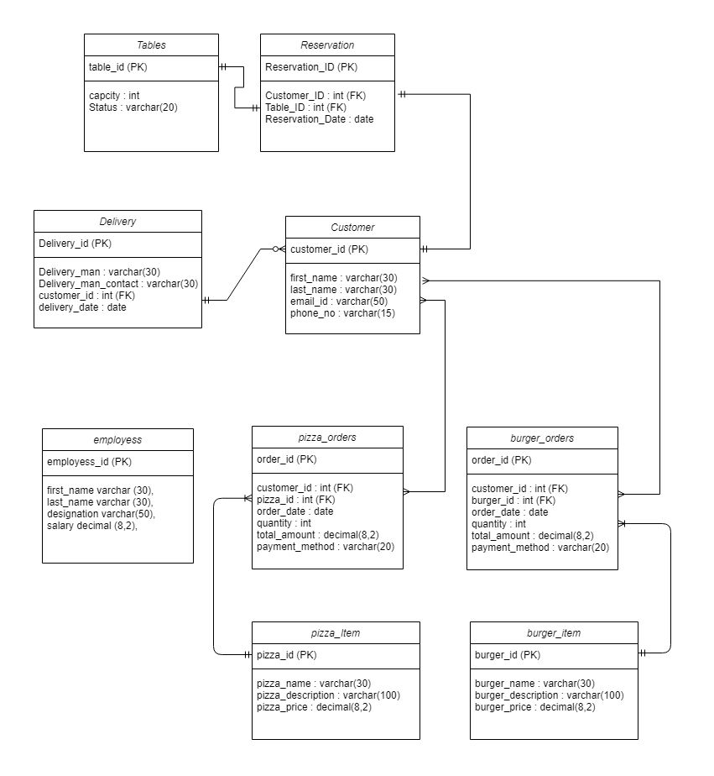

**Create Database:**

create database fast_food_deleivery

**Create Tables and Insert Values:**

create table customer(

customer_id int primary key,

first_name varchar (30),

last_name varchar (30),

email_id varchar (50),

phone_no varchar (15)

);

insert into customer values

(1,'Saria','Rukhsar','sariarukhsar5@gmail.com','0341-6451972'),

(2,'Umer','Ilyas','ui14@gmail.com','0304-403253'),

(3,'Ahmed','Shahbaz','ams9@gmail.com','0312-3467113'),

(4,'Huzaifa','Adil','hza12@gmail.com','0315-4067113'),

(5,'Haroon','Ali','hra19@gmail.com','0300-4573113');

create table pizza_item(

pizza_id int primary key,

pizza_name varchar (30),

pizza_description varchar (100),

pizza_type varchar (10),

pizza_price decimal (8,2),

);

insert into pizza_item

values(1,'royal crust pizza','classic chicken chesse pizza','L', 2000.00);

insert into pizza_item

values(2,'royal cheese pizza','classic chicken chesse pizza','L', 2500.00);

insert into pizza_item

values(3,'crown crust pizza','classic chicken chesse pizza','M', 1500.00);

insert into pizza_item

values(4,'malai crust pizza','classic chicken chesse pizza','L', 2000.00);

insert into pizza_item

values(5,'fajita pizza','classic chicken chesse pizza','S', 1000.00);

create table burger_item(

burger_id int primary key,

burger_name varchar (30),

burger_description varchar (100),

burger_price decimal (8,2)

);

insert into burger_item

values(1,'royal crust burger','classic chicken chesse burger', 500.00);

insert into burger_item

values(2,'royal cheese burger','classic chicken chesse burger', 700.00);

insert into burger_item

values(3,'crown crust burger','classic chicken chesse burger', 300.00);

insert into burger_item

values(4,'malai crust burger','classic chicken chesse burger', 400.00);

insert into burger_item

values(5,'fajita burger','classic chicken chesse burger', 500.00);

create table pizza_orders(

order_id int primary key,

customer_id int,

pizza_id int,

order_date date,

quantity int,

total_amount decimal (8,2),

payment_method varchar(20),

foreign key (customer_id) references customer(customer_id),

foreign key (pizza_id) references pizza_item (pizza_id),

);

insert into pizza_orders values

(1,1,2,'2023-09-12',1,2500.00 , 'Cash'),

(2,1,3,'2023-09-14',3,4500.00 , 'Credit Card'),

(3,3,2,'2023-09-13',2,5000.00 , 'Cash'),

(4,4,1,'2023-09-15',1,2000.00 , 'Cash'),

(5,2,5,'2023-09-12',1,1000.00 , 'Debit Card'),

(6,4,5,'2023-09-11',2,2000.00 , 'Debit Card');

create table burger_orders(

order_id int primary key,

customer_id int,

burger_id int,

order_date date,

quantity int,

total_amount decimal (8,2),

payment_method varchar(20),

foreign key (customer_id) references customer(customer_id),

foreign key (burger_id) references burger_item (burger_id),

);

insert into burger_orders values

(1,1,2,'2023-09-12',1,700.00 , 'Cash'),

(2,6,3,'2023-09-12',2,900.00 , 'Cash'),

(3,7,2,'2023-09-12',6,4200.00 , 'Debit Card'),

(4,5,1,'2023-09-15',4,2000.00 , 'Credit Card'),

(5,2,4,'2023-09-12',1,400.00 , 'Cash'),

(6,4,5,'2023-09-11',2,1000.00 , 'Cash');

Create table Tables (

table_id int primary key,

capcity int,

Status varchar(20),

);

Insert into Tables Values

(101,6,'Reserved'),

(102,4,'Reserved'),

(103,6,'Available'),

(104,2,'Available'),

(105,4,'Reserved');

Create Table Reservation (

Reservation_ID int primary key,

Customer_ID int,

Table_ID int,

Reservation_Date date,

Foreign key (Customer_ID) references customer(customer_id),

Foreign key (Table_ID) references Tables (table_id),

);

Insert into Reservation Values

(1,5,101,'2023-07-09'),

(2,3,102,'2023-07-09'),

(3,9,105,'2023-07-10');

create table employees(

employees_id int primary key,

first_name varchar (30),

last_name varchar (30),

designation varchar(50),

salary decimal (8,2),

);

insert into employees

values(1,'saad','ali','Cashier',5000.00);

insert into employees

values(2,'asad','ali','Cook',20000.00);

insert into employees

values(3,'saud','ali','Cook',50000.00);

insert into employees

values(4,'zaid','ali','Manager',45500.00);

insert into employees

values(5,'shakeel','ali','Waiter',500.00);

Create Table Delivery (

Delivery_id int primary key,

Delivery_man varchar (30),

Delivery_man_contact varchar(30),

customer_id int,

delivery_date date,

foreign key (customer_id) references customer(customer_id)

);

insert into Delivery values

(1, 'Ali' , '0332-4582701' , 2 , '2021-08-14'),

(2, 'Ahsan', '0341-5509011' , 4 , '2021-01-19'),

(3, 'Saad', '0341-5509341' , 6 , '2021-01-29');

**Procedures and Query’s:**

--Select all records from the customer table:

SELECT * FROM customer;

--Select all records from the pizza_item table:

SELECT * FROM pizza_item;

--Select all records from the burger_item table:

SELECT * FROM burger_item;

--Select all records from the pizza_orders table:

SELECT * FROM pizza_orders;

--Select all records from the burger_orders table:

SELECT * FROM burger_orders;

--Select all records from the Tables table:

SELECT * FROM Tables;

--Select all records from the Reservation table:

SELECT * FROM Reservation;

--Select all records from the employees table:

SELECT * FROM employees;

--Select the first name and last name of all customers:

SELECT first_name, last_name FROM customer;

--Select the pizza names and their prices:

SELECT pizza_name, pizza_price FROM pizza_item;

--Select the burger names and their prices:

SELECT burger_name, burger_price FROM burger_item;

--Select the order_id, customer_id, and total_amount from the pizza_orders table:

SELECT order_id, customer_id, total_amount FROM pizza_orders;

--Select the order_id, customer_id, and total_amount from the burger_orders table:

SELECT order_id, customer_id, total_amount FROM burger_orders;

--Select the table_id and capacity of all tables:

SELECT table_id, capcity FROM Tables;

--Select the reservation_id, customer_id, and reservation_date from the Reservation table:

SELECT Reservation_ID, Customer_ID, Reservation_Date FROM Reservation;

--Select the first name, last name, and salary of all employees:

SELECT first_name, last_name, salary FROM employees;

--Count the total number of customers in the customer table:

SELECT COUNT(customer_id) AS total_customers FROM customer;

--Calculate the average pizza price:

SELECT AVG(pizza_price) AS average_pizza_price FROM pizza_item;

--Calculate the total amount spent by each customer in pizza orders:

SELECT customer_id, SUM(total_amount) AS total_spent FROM pizza_orders GROUP BY customer_id;

--Find the highest pizza price:

SELECT MAX(pizza_price) AS highest_pizza_price FROM pizza_item;

--Find the lowest pizza price:

SELECT MIN(pizza_price) AS lowest_pizza_price FROM pizza_item;

--Find the customer who spent the most on burger orders:

SELECT top 1 customer_id, MAX(total_amount) AS max_spent FROM burger_orders GROUP BY customer_id ORDER BY max_spent DESC;

--Find the customer who placed the first pizza order:

SELECT top 1 customer_id, MIN(order_date) AS first_pizza_order FROM pizza_orders GROUP BY customer_id ORDER BY first_pizza_order ASC;

--Calculate the total earnings from pizza orders:

SELECT SUM(total_amount) AS total_earnings FROM pizza_orders;

--Calculate the total earnings from burger orders:

SELECT SUM(total_amount) AS total_earnings FROM burger_orders;

--Find the busiest day with the most pizza orders:

SELECT top 1 order_date, COUNT(order_id) AS pizza_orders_count FROM pizza_orders GROUP BY order_date ORDER BY pizza_orders_count DESC;

--Find the number of available tables:

SELECT COUNT(table_id) AS available_tables FROM Tables WHERE Status = 'Available';

--FIND NUMBER OF RESEVERD TABLE

SELECT COUNT(table_id) AS reserved_tables FROM Tables WHERE Status = 'Reserved';

--Retrieve all delivery records:

SELECT * FROM Delivery;

--Retrieve delivery details for a specific delivery ID:

SELECT * FROM Delivery WHERE Delivery_id = 1;

--Retrieve delivery details for a specific customer ID:

SELECT * FROM Delivery WHERE customer_id = 2;

--Retrieve delivery records for a specific delivery date:

SELECT * FROM Delivery WHERE delivery_date = '2021-08-09';

--Retrieve deliveries along with customer information for a specific delivery man

SELECT Delivery.Delivery_id,Delivery.Delivery_man,Delivery.Delivery_man_contact,Delivery.delivery_date,Delivery.customer_id, customer.first_name, customer.last_name, customer.phone_no

FROM Delivery

inner JOIN customer ON Delivery.customer_id = customer.customer_id

WHERE Delivery_man = 'Ali';

--Retrieve the count of deliveries for each delivery man:

SELECT Delivery_man, COUNT(*) AS delivery_count

FROM Delivery

GROUP BY Delivery_man;

--Update the delivery date for a specific delivery ID:

select * from Delivery UPDATE Delivery

SET delivery_date = '2021-08-15'

WHERE Delivery_id = 2;

--Retrieve all pizza orders with customer information:

CREATE PROCEDURE PIZZA_ORDER_INFO

AS

BEGIN

SELECT pizza_orders.order_id, pizza_orders.order_date, pizza_orders.total_amount, pizza_orders.payment_method, customer.first_name, customer.last_name, customer.email_id,

customer.phone_no

FROM pizza_orders

inner JOIN customer ON pizza_orders.customer_id = customer.customer_id;

END;

exec PIZZA_ORDER_INFO

--Retrieve all burger orders with customer information:

SELECT burger_orders.order_id, burger_orders.order_date, burger_orders.total_amount, burger_orders.payment_method, customer.first_name, customer.last_name, customer.email_id,

customer.phone_no

FROM burger_orders

inner JOIN customer ON burger_orders.customer_id = customer.customer_id;

--Retrieve all pizza orders along with the pizza details:

SELECT pizza_orders.order_id, pizza_item.pizza_name, pizza_item.pizza_type, pizza_item.pizza_price, pizza_orders.quantity, pizza_orders.total_amount

FROM pizza_orders

inner JOIN pizza_item ON pizza_orders.pizza_id = pizza_item.pizza_id;

--Retrieve all burger orders along with the burger details:

SELECT burger_orders.order_id, burger_item.burger_name, burger_item.burger_price, burger_orders.quantity, burger_orders.total_amount

FROM burger_orders

inner JOIN burger_item ON burger_orders.burger_id = burger_item.burger_id;

--Retrieve all reserved tables along with the customer information who made the reservation:

SELECT Reservation.Reservation_ID, Tables.table_id, Tables.Status, customer.first_name, customer.last_name, customer.email_id, customer.phone_no

FROM Reservation

inner JOIN Tables ON Reservation.Table_ID = Tables.table_id

inner JOIN customer ON Reservation.Customer_ID = customer.customer_id;

--Retrieve all pizza orders with customer names and pizza details:

SELECT pizza_orders.order_id, customer.first_name, customer.last_name, pizza_item.pizza_name, pizza_item.pizza_type, pizza_orders.quantity, pizza_orders.total_amount

FROM pizza_orders

inner JOIN customer ON pizza_orders.customer_id = customer.customer_id

inner JOIN pizza_item ON pizza_orders.pizza_id = pizza_item.pizza_id;

--Retrieve all burger orders with customer names and burger details:

SELECT burger_orders.order_id, customer.first_name, customer.last_name, burger_item.burger_name, burger_item.burger_price, burger_orders.quantity, burger_orders.total_amount

FROM burger_orders

inner JOIN customer ON burger_orders.customer_id = customer.customer_id

inner JOIN burger_item ON burger_orders.burger_id = burger_item.burger_id;

--Retrieve the total number of pizza and burger orders placed by each customer:

SELECT customer.first_name, customer.last_name, COUNT(pizza_orders.order_id) AS pizza_orders, COUNT(burger_orders.order_id) AS burger_orders

FROM customer

LEFT JOIN pizza_orders ON customer.customer_id = pizza_orders.customer_id

LEFT JOIN burger_orders ON customer.customer_id = burger_orders.customer_id

GROUP BY customer.customer_id, customer.first_name, customer.last_name;

--Retrieve the total sales amount for each pizza type:

SELECT pizza_item.pizza_type, SUM(pizza_orders.total_amount) AS total_sales

FROM pizza_orders

inner JOIN pizza_item ON pizza_item.pizza_id = pizza_item.pizza_id

GROUP BY pizza_item.pizza_type;

--Retrieve the average salary of employees for each designation:

SELECT designation, AVG(salary) AS average_salary

FROM employees

GROUP BY designation;

--Retrieve the count of available and reserved tables:

SELECT Status, COUNT(*) AS count_of_tables

FROM Tables

GROUP BY Status;

--Retrieve all pizza orders along with the corresponding customer and table information (if reserved):

CREATE PROCEDURE PROC5

AS

BEGIN

SELECT pizza_orders.order_id, customer.first_name, customer.last_name, customer.email_id, customer.phone_no, Tables.table_id, Tables.Status

FROM pizza_orders

inner JOIN customer ON pizza_orders.customer_id = customer.customer_id

LEFT JOIN Reservation ON pizza_orders.customer_id = Reservation.Customer_ID

LEFT JOIN Tables ON Reservation.Table_ID = Tables.table_id;

END;

EXEC PROC5

--Retrieve all burger orders along with the corresponding customer and table information (if reserved):

CREATE PROCEDURE PROC4

AS

BEGIN

SELECT burger_orders.order_id, customer.first_name, customer.last_name, customer.email_id, customer.phone_no, Tables.table_id, Tables.Status

FROM burger_orders

inner JOIN customer ON burger_orders.customer_id = customer.customer_id

LEFT JOIN Reservation ON burger_orders.customer_id = Reservation.Customer_ID

LEFT JOIN Tables ON Reservation.Table_ID = Tables.table_id

END;

EXEC PROC4

--Retrieve the total number of pizza and burger orders served by each employee:

CREATE PROCEDURE PROC3

AS

BEGIN

SELECT employees.employees_id, employees.first_name, employees.last_name, employees.designation,

COUNT(pizza_orders.order_id) AS pizza_orders_served, COUNT(burger_orders.order_id) AS burger_orders_served

FROM employees

LEFT JOIN pizza_orders ON employees.employees_id = pizza_orders.customer_id

LEFT JOIN burger_orders ON employees.employees_id = burger_orders.customer_id

GROUP BY employees.employees_id, employees.first_name, employees.last_name, employees.designation

END;

EXEC PROC3

--Retrieve all pizza orders with delivery details (if delivered):

create procedure PROC2

AS

BEGIN

SELECT pizza_orders.order_id, customer.first_name, customer.last_name, customer.email_id, customer.phone_no, Delivery.Delivery_man, Delivery.Delivery_man_contact,

Delivery.delivery_date

FROM pizza_orders

inner JOIN customer ON pizza_orders.customer_id = customer.customer_id

LEFT JOIN Delivery ON pizza_orders.customer_id = Delivery.customer_id;

END;

EXEC PROC2

--Retrieve all burger orders with delivery details (if delivered):

create procedure proc1

as

Begin

SELECT burger_orders.order_id, customer.first_name, customer.last_name, customer.email_id, customer.phone_no, Delivery.Delivery_man, Delivery.Delivery_man_contact,

Delivery.delivery_date

FROM burger_orders

inner JOIN customer ON burger_orders.customer_id = customer.customer_id

LEFT JOIN Delivery ON burger_orders.customer_id = Delivery.customer_id ;

end;

exec proc1

select customer.first_name,customer.last_name,(count(pizza_orders.quantity)+

count(burger_orders.quantity)) as TOTAl from customer

left join pizza_orders on customer.customer_id= pizza_orders.customer_id

left join burger_orders on burger_orders.customer_id = customer.customer_id

where pizza_orders.quantity>0 or burger_orders.quantity>0

GROUP BY

customer.first_name,customer.last_name

;